|  |  |  |
| --- | --- | --- |
| scan0002 | HAWAII ISLAND TEEN COURT | T-shirt logo |
| Ka leo `o na pua ⚫ The voice of youth |
| **a program of the ywca of hawai`i island** |

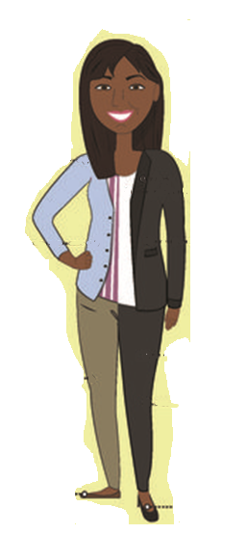

**SHOES.**

Closed toed shoes are preferable. But Teen Court understands we are in Hawaii. If you are to wear open toed shoes they should not be rubber slippers.

**Professional Role Court Attire**

If you want to be a Clerk, Bailiff, Attorney, Case Presenter or Judge you need to dress the part! Here are the guidelines for these roles.

**PIERCINGS AND JEWLERY.**

Less is more. Watches, bracelets, earrings are ok. Please limit the amount of jewelry on arms and neck. No inappropriate symbols/sayings on jewelry.

**HAIR.**

Keep it looking natural-No bright or unnatural colors. Pull long hair back with ties or clips

**PANTS, SHORTS & SKIRTS.**

The bottom half of your outfit needs to be no more than four inches above the knees. Slacks in black or khaki are preferred, but clean jeans will be ok.

**HATS.**

All hats must be removed before the hearing starts.

**SHIRTS.**

No inappropriate language or symbols. You will be provided with a Teen Court Shirt during a hearing.